**INTEGRATION TESTING**

TESTCASES FOR INTEGRATION TESTING:

TESTCASE 1:

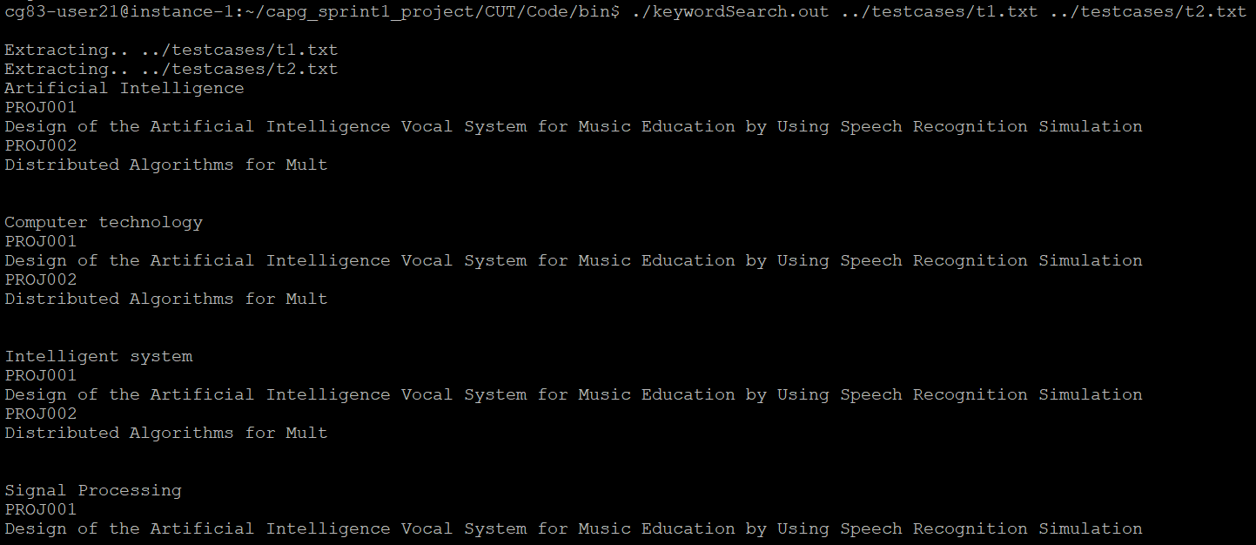

TESTCASE 2:

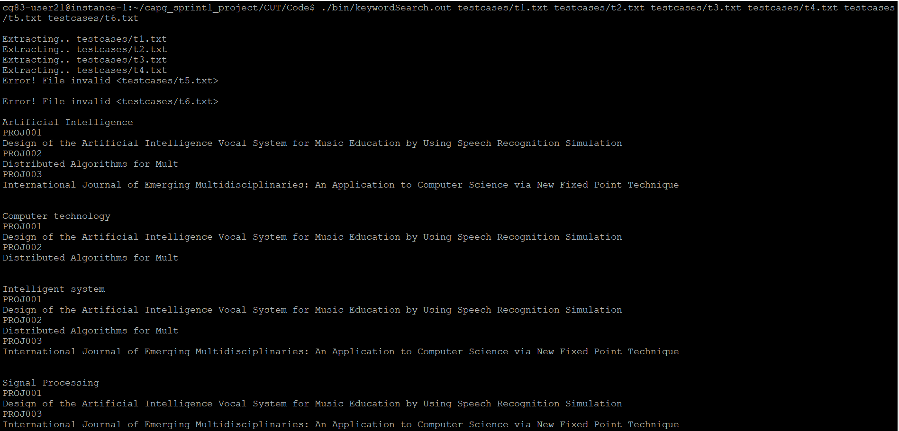



TESTCASE 3:

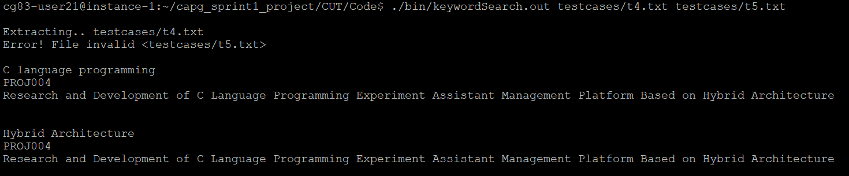

TESTCASE 4:

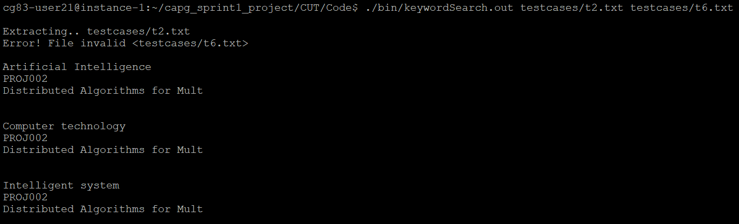

TESTCASE 5:



TESTCASE 6:

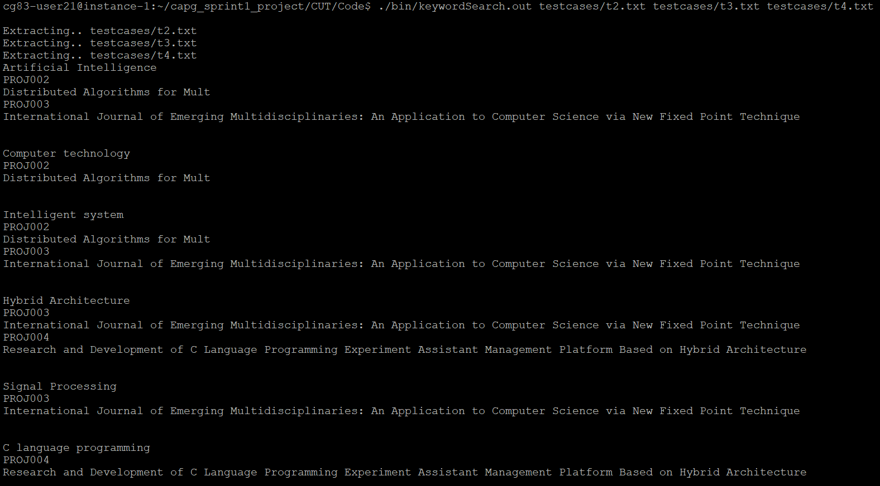

TESTCASE 7:

